Pledge-Pop Campaigning Product App
Section 1: System Overview
- 1.1 What is this system?
- 1.2 Key concepts (Deposit, Target, Balance, Auto-capture, Balance invoice)
- 1.3 Overall flow (7 steps)

Section 2: Customer Pledge – Deposit Webhook
- 2.1 Frontend – pledge button & cart add with _campaign_id
- 2.2 Shopify order creation & webhook trigger
- 2.3 Webhook handling – deposit order
- 2.4 Database state after deposit

Section 3: Auto‑Capture – Deposits Capture & Balance Invoices
- 3.1 Main auto-capture function (triggerAutoCapture)
- 3.2 Deposit capture – orderCapture mutation
- 3.3 Balance invoice – draftOrderCreate + draftOrderInvoiceSend
- 3.4 Database state after auto-capture

Section 4: Balance Payment Webhook & Final Status Update
- 4.1 Detecting a balance payment order (custom attributes)
- 4.2 Webhook logic for balance payment
- 4.3 Database state after balance payment

Section 5: Key Shopify GraphQL Mutations Summary
- orderCapture
- draftOrderCreate
- draftOrderInvoiceSend

Section 6: Complete Flow Diagram
- Step-by-step flow from pledge to full payment

Section 7: Error Handling & Logging
- Duplicate webhook prevention
- Deposit already captured skip
- Missing campaign ID handling
- Invoice send warnings (manual resend option)

Section 1: System Overview
1.1 What is this system?
This is a crowdfunding-style payment system built for Shopify.
It allows a merchant to launch a campaign on a product where customers pay a small deposit upfront, and when the campaign reaches its funding target, the remaining payment is automatically collected via email invoice.
1.2 Key concepts (Deposit, Target, Balance, Auto‑capture, Balance invoice)
Term | Meaning
Deposit | Small amount the customer pays at checkout (e.g., $2). This is authorized (funds on hold) but not captured immediately.
Target | Total deposit amount needed to fund the campaign (e.g., 50 units × $2 = $100).
Payment | Remaining amount after deposit: Product price – Deposit (e.g., $100 – $2 = $98).
Auto-capture | Automatic process triggered when the campaign reaches 100% funding. It does two things: captures all pending deposits and sends payment invoices.
Balance Payment invoice | A Shopify draft order sent via email to the customer, asking them to pay the remaining amount.

1.3 High‑level flow
- Customer pledges – Clicks "Pledge $2 Now" on the product page, goes through checkout, pays the deposit (authorization).
→ Shopify sends an ORDERS_PAID webhook to our app.
- Webhook (deposit) – Creates a Backer record in the database, stores the remainingAmount, updates campaign progress.
- Campaign reaches 100% – The webhook detects that fundingPercentage >= 100 and calls triggerAutoCapture().
- Auto-capture –
  - Captures all pending deposits (converts authorization to actual payment).
  - For each backer with a remaining balance, creates a draft order and sends an invoice email.
- Customer pays balance – Clicks the link in the invoice, pays the remaining amount.
→ Shopify sends another ORDERS_PAID webhook, but this time the order has a special attribute _type: "balance_payment".
- Webhook (balance) – Detects the balance payment, updates the backer’s remainingAmount to 0 and paymentStatus to "captured".
- Merchant sees results – On the campaign details page, the backer moves from "Pending" to "Captured" table.

Section 2: Customer Pledge – Deposit Webhook
2.1 Frontend – How the pledge button works:
When a customer visits a product page that has an active campaign, the Liquid widget extension/block/campaign-preview.liquid renders a button with data attributes:
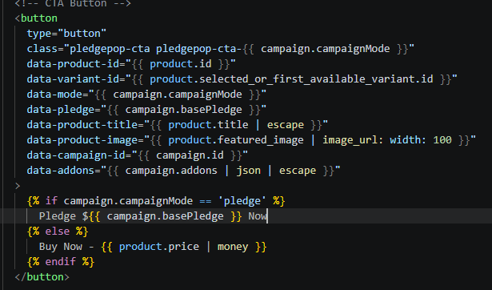 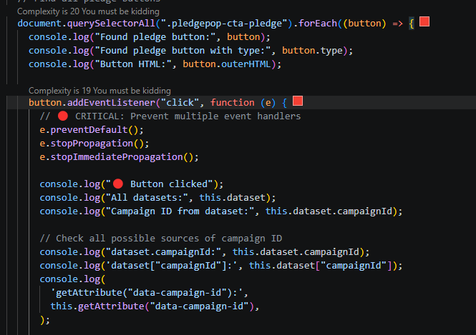
With the help of extension/assets/campaign.js, we can see the response in Console:
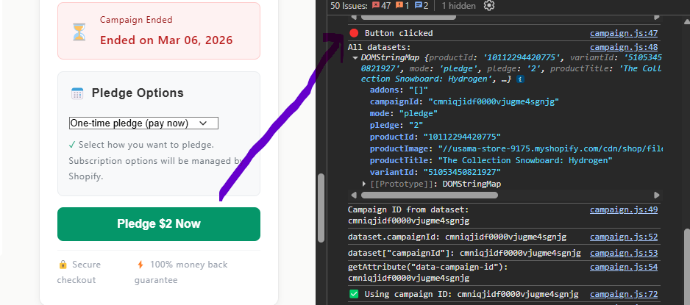

Extension/assets/campaign.js listens for clicks on this button

Opens a modal where the customer can select add‑ons (optional).

On confirmation, it adds the main product to the cart with custom properties using Shopify’s /cart/add.js endpoint.

The important custom property is _campaign_id, which is later used by the webhook to identify the campaign.

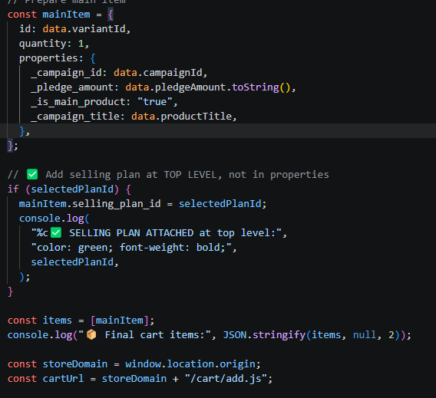
After adding to cart, the customer is redirected to Shopify checkout.

2.2 Shopify Order & Webhook Trigger:
The customer completes checkout and pays the deposit (e.g., $2).
The order status becomes “Authorized” (not yet captured).
Shopify sends a POST request to the app’s webhook endpoint:
app/routes/webhooks/app/orders-paid
2.3 Webhook Handling – Deposit Order:
File: app/routes/webhooks.app.orders-paid.jsx
The webhook performs the following steps:
Authenticate the webhook using authenticate.webhook(request).
Extract campaign ID from the line-item properties:
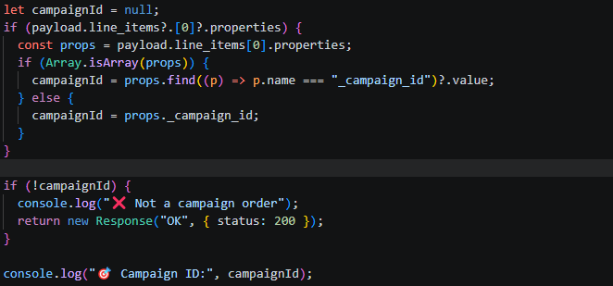

Calculate remaining amount (product price – deposit):
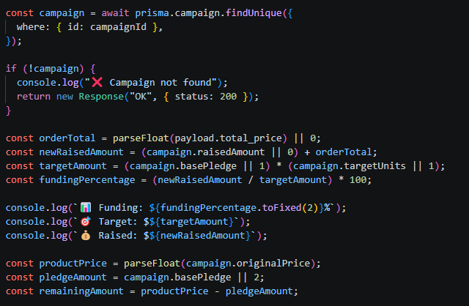

Create the backer Record in the Database
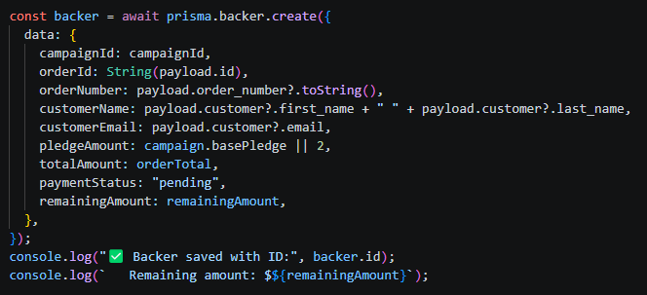

Update campaign (raised amount, backers count, funding percentage)
Check if campaign reached 100% funding. If yes, mark the campaign as completed and call triggerAutoCapture() (detailed in Section 3)

2.4 Key Database Fields After Deposit
Field | Value | Meaning
paymentStatus | "pending" | Deposit is authorized but not captured.
remainingAmount | 98 | Customer still owes $98.
balanceInvoiceSent | false | No balance invoice sent yet.

Section 3: Auto‑Capture – Deposits Capture & Payment Invoices
When the campaign reaches 100% funding, the webhook calls triggerAutoCapture(campaignId, admin).
This function is defined in app/utils/autoCapture.js.

3.1 Main Auto‑Capture Function
Capture all pending deposits

Send balance invoices for remaining amount

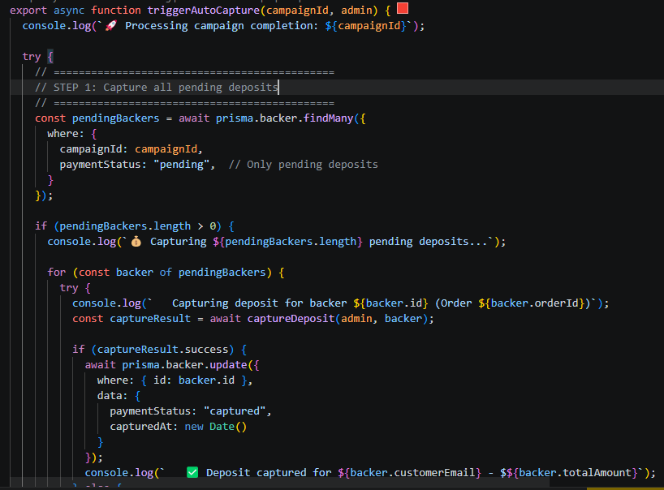
3.2 Deposit Capture – orderCapture Mutation
The captureDeposit function uses Shopify’s GraphQL mutation orderCapture to convert an authorized transaction into a captured payment.
Steps inside captureDeposit:
- Check if already captured – to avoid “already captured” errors.
- Get the authorization transaction ID (the AUTHORIZATION transaction that was created during checkout).
- Call the orderCapture mutation with the order ID, parent transaction ID, and amount.
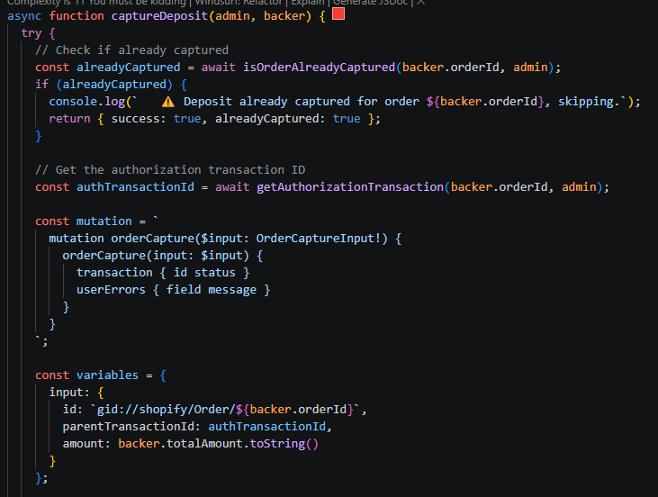

What this mutation does:
- Finds the existing authorization transaction (the hold).
- Captures the exact amount.
- Changes the order payment status from “Authorized” to “Paid”.
- Money is transferred to the merchant’s account.

3.3 Payment Invoice – draftOrderCreate + draftOrderInvoiceSend
For each backer with remainingAmount > 0, we create a draft order and send an invoice.
Step 1: Create Draft Order (draftOrderCreate mutation)
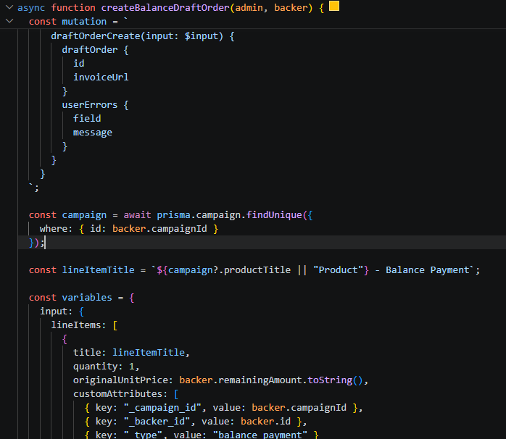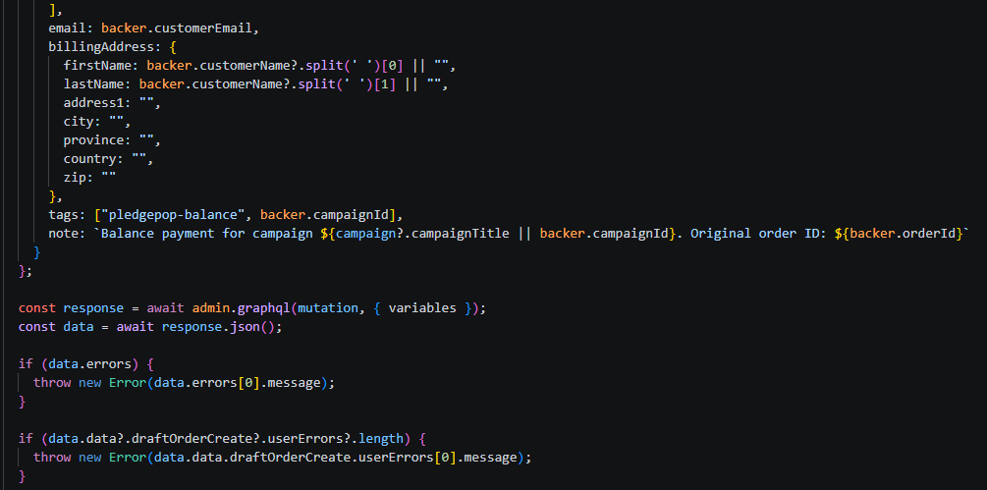
What this does:
- Creates a draft order (not a real order yet).
- The line-item price = remainingAmount.
- Adds custom attributes so the webhook can later identify this as a balance payment.

Step 2: Send Invoice (draftOrderInvoiceSend mutation)
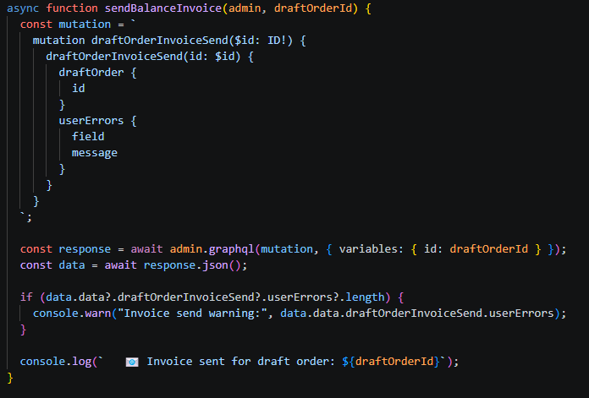
What this does:
- Shopify emails the customer an invoice containing a payment link.
- The customer can click the link and pay the remaining amount using a credit card or other payment method.

3.4 After Auto‑Capture – Database Updates
After successful deposit capture and Payment invoice:
Backer Field | Before Auto‑Capture | After Auto‑Capture
paymentStatus | "pending" | "captured" (deposit captured)
capturedAt | null | timestamp
balanceInvoiceSent | false | true
balanceInvoiceSentAt | null | timestamp
balanceOrderId | null | draft order ID

Section 4: Balance Payment Webhook & Final Status Update

When the customer receives the balance payment invoice email and clicks the “Pay now” link, they complete the payment for the remaining amount (e.g., $98). This triggers another ORDERS_PAID webhook.

4.1 Detecting a Balance Payment Order
The draft order we created earlier included custom attributes
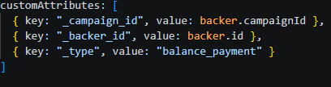

When the customer pays, Shopify converts the draft order into a real order, and these custom attributes are copied to the order’s line items. The webhook reads them to identify that this is a balance payment, not a new deposit.

4.2 Webhook Logic for Balance Payment
Inside webhooks.app.orders-paid.jsx, before processing a normal deposit, the webhook checks for _type: "balance_payment":
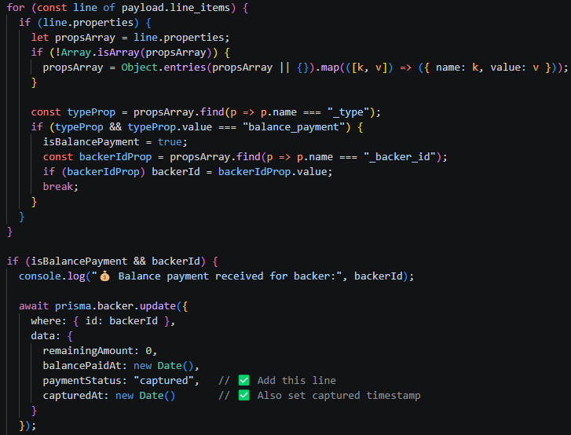

4.3 What Happens After Update
- remainingAmount becomes 0 – the customer owes nothing more.
- paymentStatus becomes "captured" – the deposit + balance is now fully paid.
- balancePaidAt stores the timestamp of the final payment.

Now, when the merchant views the campaign details page (/app/campaigns/$id), the backer moves from the “Pending Payments” table to the “Captured Payments” table.

Section 5: Key Shopify GraphQL Mutations Summary

Mutation | Purpose | Used In
orderCapture | Converts an authorized transaction into a captured payment (deposit capture). | autoCapture.js → captureDeposit()
draftOrderCreate | Creates a draft order for the balance amount. | autoCapture.js → createBalanceDraftOrder()
draftOrderInvoiceSend | Sends an invoice email to the customer for the draft order. | autoCapture.js → sendBalanceInvoice()

Section 6: Complete Flow Diagram

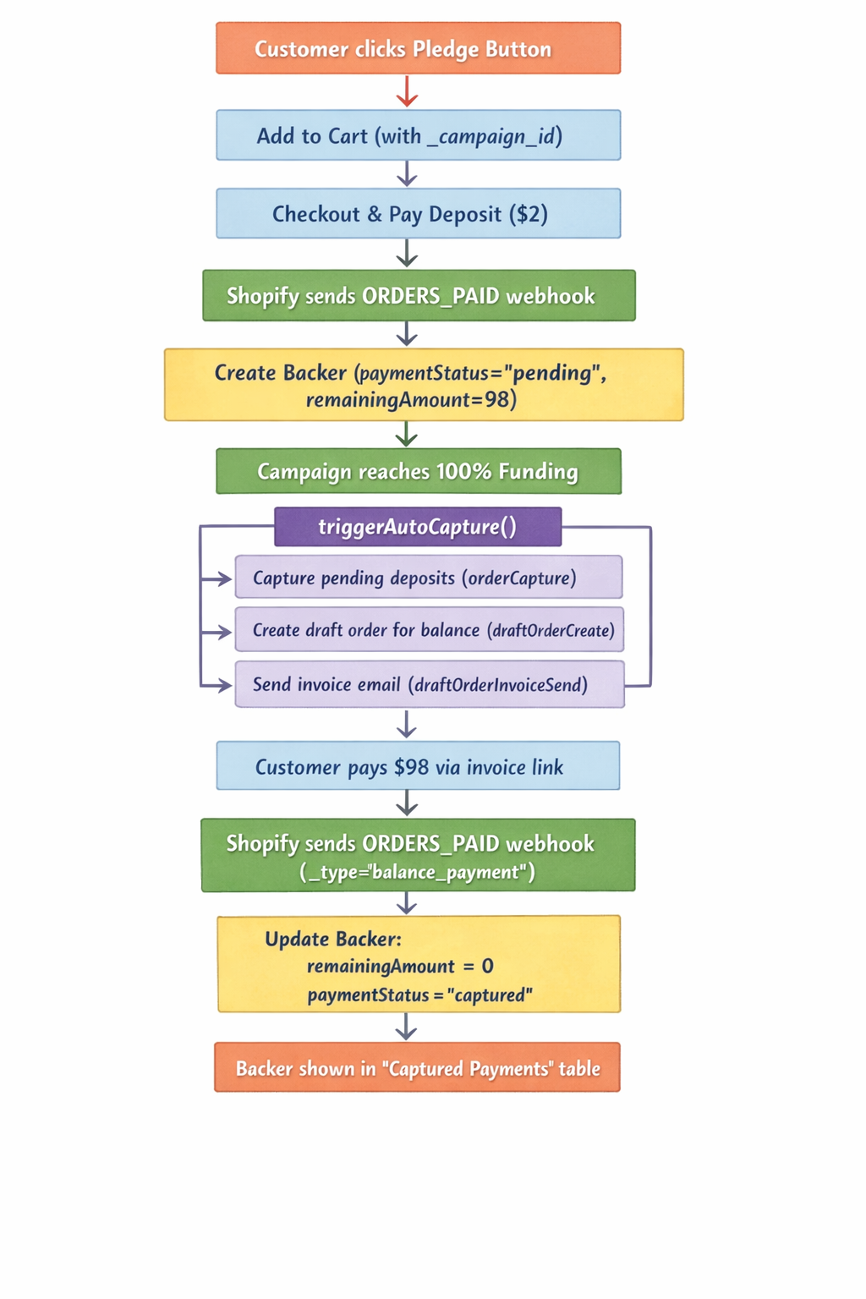

Section 7: Error Handling & Logging
Duplicate webhook calls:
- Shopify retries failed webhooks. The webhook checks for an existing Backer by orderId before creating a duplicate.
Deposit already captured:
- The captureDeposit function first checks if a capture transaction already exists and skips gracefully.
Missing campaign ID:
- If _campaign_id is not found, the webhook returns OK (no action).
Balance invoice send warning:
- If Shopify cannot send the invoice automatically (e.g., customer email not verified), the merchant can manually resend from the Shopify admin under Orders → Drafts.

